**September 2015**

**Newsletter**



Welcome to kindergarten!

**Helping young students to learn and grow**

Through instruction and play-based learning, children in full-day kindergarten:

* develop socially and emotionally through interaction with their peers and the adults who teach and guide them
* develop their capacity in language and mathematics
* engage in healthy physical activities and the arts

The program has two components.  In the core component, one teacher and one early childhood educator will work together in each classroom to help children learn during the regular school day.  The optional extended day component includes [before- and after-school programs](http://www.peelschools.org/parents/programs/kindergarten/full-day/extendedday)led by early childhood educators.

**For more information on this article, please visit http://www.theglobeandmail.com/news/national/education/parents-researchers-hopeful-of-positive-effects-from-ontarios-full-day-kindergarten/article14083441/**

Important Info

**Information and Points to Remember**

Principal: Matthew McCutcheon

Vice-Principal: Christina Brulotte, Jennifer Stegeman

Office Manager: TBD

Office Assistant: Christine Keyes

Kindergarten Teacher: Natalie Winter

ECE Teacher: Lakhwinder Saini

School Phone Number: 905-843-3281

School Fax Number: 905–843–3285

**School Begins at 8:25 am and**

**dismissal is at 2:50 pm**

**Attendance**

We have a Safe Arrival Program at our school. Please inform the school by calling before the school day begins, if you know your child will be absent.

**Entry**

As students arrive at school they may wait in the Kindergarten Area after 8:15 am when supervision starts. When the bell rings, the children will line up one behind the other and enter the school when we meet them at the door. Parents are asked to say their good-byes outside the fence since the students need to develop independence early in the school year.

**Late Arrival**

If your child is late, please take him/her to the office.

**Pick-Ups / Dismissal**

All students will be dismissed from the Kindergarten Area. It is important that your child knows who will be picking him/her up at dismissal. **Please inform us if your child will be picked up by someone new.**

**Change of Information**

Please notify us and the office of any change of information pertaining to your child as this is a safety issue (baby-siting arrangements, new phone numbers, person picking up your child).

reminders

**Mailbag**

We will provide each child with a message bag that will be used to carry newsletters, calendars, parent forms, completed work, etc. to your home safely. Please empty the bag, read the information and **return the bag each day**.

**Parent / Teacher Communication** A Kindergarten calendar and newsletter will be sent home each month. These will let you know what we are doing in the classroom. If you would like to send us a note, please ensure it is inside your child’s message bag. Please feel free to contact us by phone, notes or in person.

**What Did You Do Today?** Author Unknown

When children come home at the end of the day The question they’re asked as they scurry to play is “Tell me, what did you do today?” And the answer they give makes you sigh with dismay,

“Nothing, I did nothing today!” Perhaps nothing means that I played with dinosaur creatures,

Or counted to ten with my teacher. Maybe I painted a picture of red and blue. Or heard a story about a mouse that flew. Maybe I watched the gerbils eat today, Or went outside on the swings to play. Maybe today was the very first time That my scissors followed a very straight line. Maybe I led a song from beginning to end Or played with a brand new friend. When you’re only five and your heart has wings, NOTHING can mean so many things!

Student attendance

Please call the centre if your child will be absent, late or if you will not be able to pick up your but are sending someone else to pick up and please remind that person to have their Photo ID on them when picking up your child. This is to ensure the safety and well being of your child.

Drop off and pick up

Parents please drop off and pick up your child (ren) at the kindergarten doors. This is to ensure the safety of your child as well as it gives staff and parents time to communicate with each other about up-coming events, activities, concerns, how your child’s day went etc…

attire

The weather lately has been quite unpredictable. The mornings have been really cold and some afternoons have been nice and warm. When sending your child to school, please dress your child according to the weather (morning and afternoon). We are required to take the children outdoors for 45 minutes a day so please make sure your child is dressed appropriately for the outdoors.

extra change of clothes

**We kindly ask parents/guardians to provide an extra change of clothes (seasonal clothing) for your child. At times, children will get messy or have accidents throughout the day so if you could please keep an extra change of clothes in their back-packs at all times that would be great! Also, please remind your child not to leave their extra change of clothes in their classroom because it is quite difficult for us to leave our program to retrieve their clothes from another classroom. Thanks!**

or take them out of their bag when in the YMCA care unless, it is for a show and share activity. Thank you for your understanding and co-operation.

allergies

This YMCA sites are peanut and nut free zones but there are other allergies that we have to be aware of! We understand that the children have their bagged lunches and snacks for when they go to school but they are to be kept in their backpacks when they are at the YMCA before and after school care. We appreciate your co-operation!

**EDP 102**

**February**

The month of February was lots of fun with tons of different things going on in our room. We stayed busy with food and turning our home center into a restaurant. We learned about different food groups, decorated cupcakes and even hosting a grand opening of our restaurant. We also had fun doing activities all about our letters and shapes. We made shapes and letter on our geoboards with elastic bands, made letters with our whole bodies and matching our shapes with the names. Then came Valentine’s Day! An exciting time filled with valentine’s parties in the home center, making valentines cards and bracelets for our friends and families and even making flowers out of pipe cleaners and tissue paper. During this time we were also working on our Read-a-thon, raising money for strong kids. The children loved reading as many books as they could to work on our grand total in the center towards our goal. From there the children had a blast learning all about butterflies, how they started and all the different colours they could be. Mixing colours was also a big interest, having fun mixing lots of paint colours and even different colour waters was a lot of messy fun for everyone. We can't wait to see what happens next!

**March**

This month, the children participated in a number of fun activities, such as: pretending to be at the beach, exploring the Safari and observing safari animals, turning the home center into a Pizza parlor, building and talking about different cities and celebrating St. Patrick's Day. Throughout these activities, Brianna, Hayden, Jaylen and Ashley pretended that they were having a pizza party in the home center. Sebastian, Katarina and Megan pretended that they were Safari Animal and they were out hunting animals for food. Lucas and Brianna used the coffee filters to make safari hats. Miguel, Nate, Skylar and Luca used the city lego's to build a city with wooden people and a train station, they say it was the city of Toronto.

The children were super excited about the beach activities. They created a beach using sand, stones, seashells and water, and constructed boats out of lego's to use at the beach. They also pretended that they were having a picnic and a beach party at the beach. Skylar , Catherine, Alexander, Salvatore and Laura planted plastic trees in the sand. They said that they were making a tree house beside the beach, so that they can go inside when the sun gets too hot and when they felt sleepy. For St. Patrick's day, the children made cup cakes and decorated them

with green icing. They made patterns with shamrocks and buildings with sugar cubes and painted them green. We concluded the celebration with an awesome St. Patrick's Day Party.

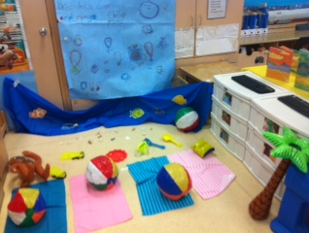 **The Beach! Woowhoo!**

**From your Extended Day Program Teachers,**

**Jessica and Josette ☺**

**SA Stage**

**February**

Last month the children on the stage participated in a variety of activities. One of the highlights this month was the art gallery that we set up on the stage. The children were able to create their own artwork and then we decorated the stage and set it up to look like our very own art gallery. Jared decided he wanted to run the ticket booth where we gave tickets to all of the visitors to the gallery and he did a great job! Colby and Jordan were tour guides that showed our visitors from kindergarten around the art gallery. The children were also interested in music so we spent some times doing activities around music; one of which was setting up a cup xylophone that Aqeal had a lot of fun experimenting with. The children also got to make instruments using materials they could find around the house. For example we made guitars using tissue boxes, elastic bands and paper towel rolls. Charlize and Isabelle really enjoyed creating their own instruments. Of course we couldn’t spend some time doing music activities without doing something with American Idol. Natasha G. and Katie were excited to emulate their favourite judges while Gabby and Chiara tried to sing their way to a golden ticket. The children were also interested in Star Wars so Jacob and Nathan spent some time making Star Wars spaceships using the Lego. We can’t forget Valentine’s Day either! We did a few different activities leading up to Valentine’s Day including making cards, decorations and baking heart-shaped cookies. Emma and Isabella like creating different Valentine’s crafts and of course the cookies were a big hit with everyone!

**March**

This month the children had some diverse interests that we explored with various activities. To start off the month, the children were interested in transportation. Some of the children designed their own paper airplanes and enjoyed seeing who could get their plane to do the coolest trick or fly the farthest. Nathan, Elijah and Connor were particularly good pilots! Daniel, Jacob and Chiara also had a lot of fun building their own boats using straws, construction paper and tape. They experimented with different materials to see who could get their boat to float best. Another popular activity we did this month was building different vehicles using marshmallows and toothpicks. It wasn’t surprising that the children showed interest in an activity that involved marshmallows. Natasha T., Charlize and Emma were a few of the children that really enjoyed getting creative with this activity. From transportation the children’s interest shifted to Princes, Princesses and castles. We played a game called giants, wizards

Spring Cleaning

**Spring cleaning**? Don't dump it; **donate** it to St. Aidan YMCA. We would gladly take any gently used household items such as, pots and pans, clothing, shoes, toys, etc. This will give children more materials to expand their interests and learning capabilities.

Thank you!

Article Title

The purpose of a holiday newsletter is to keep friends and family updated on the events in your family’s life and to share holiday greetings across the miles. The year-end holidays are a good time to tell about your experiences from the past year and to express warm wishes for the year to come.

Why send a family newsletter? Most people send greeting cards to friends and loved ones at these times. A newsletter is a more informative yet convenient way of keeping in touch with those you do not see as often as you would like.

Writing a family newsletter can also be a fun activity to do together as a family. You can make everyone feel included as you take stock of the events in your life together.

First, sit down and talk about the most important things that have happened in the past year. What special memories do you share? What have you learned or come to understand? Has anyone in your family achieved any accomplishments (like a graduation from school or winning an award) or reached a major milestone (like retiring or moving into a new home)? Your family newsletter is a good place to share that information and relive those memories with people who could not be there to share your joy the first time.

Also, think about who will be reading your family newsletter. What would your friends or distant family members most like to hear about? Do they have any special interests that your family shares?

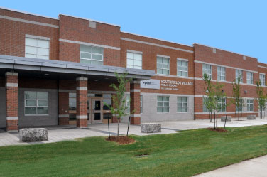

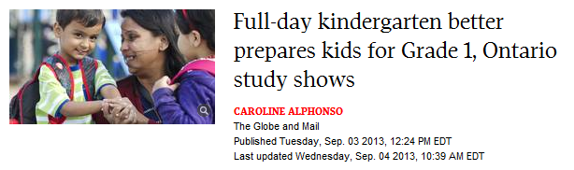

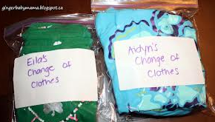



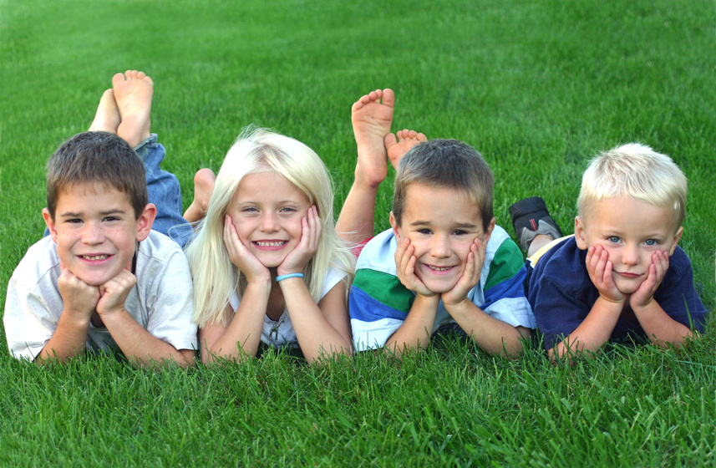

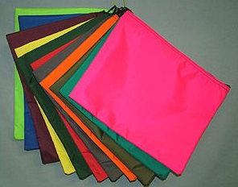

**School Bag**

It is important for each child to have a “school bag/backpack” that he/she brings to school each day. It needs to be **large** enough to carry crafts, Show and Share items, large books, lunch, snacks, etc., back and forth. Please **clearly mark** your child’s bag with his/her first and last name on an inside strap or inside the bag so strangers cannot use it negatively. Consider a wheel backpack if the weight of your child’s backpack is a concern.

**Clothing**

Some activities are messy! It is important for your child to be dressed in **comfortable play clothes** and running shoes. Keep dressy clothes for special occasions. As the cooler weather approaches, your child should wear proper clothing to keep warm during outdoor play times. We will be going outside EVERYDAY, usually twice in a day for up to an hour. We will be out when it is lightly raining as well. Students should come prepared and wear layers. All outdoor clothing needs to be labeled. Also a **change of clothes should be left at school** in case a mishap occurs. This could include: a t-shirt, a pair of pants, underwear and socks. Please place in a labeled bag and then put into a small child’s size show box. We will label the box at school.

**Indoor Shoes**

Each child needs a pair of running shoes to be left at school to wear in the classroom and in the gym. As tying laces is often difficult for Kindergarten children to do quickly and effectively, a **Velcro or slip-on** **style** is best and gives us more time for gym. Names should be clearly **labeled** on each shoe.

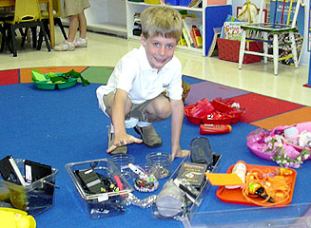

**Birthdays**

Although every child is special every day, a birthday is an extra special event in our classroom. However, due to several allergies in the classroom **no birthday food treats** are allowed.

**Donations**

We are always accepting any beautiful junk you may have but do not need. Below is a list of Beautiful Junk that we can use throughout the year. Many important skills are developed by the children's use of junk materials, and thus we need a constant supply of all sorts of junk.  Here is a list of things we can use:

* Egg cartons
* Cereal/oatmeal boxes
* Paper towel tubes
* Kleenex boxes
* Magazines (appropriate content)
* Extra stickers
* Water bottles
* Any recyclable materials

**Also,**

As we transition from fall to winter - the cold and flu season is definitely upon us. For children, cold and flu season can mean an unfortunate case of the sniffles, we kindly ask if parents/guardians if they could donate a box of Kleenex to the classroom if possible. Thank you for your support.

**We look forward to an exciting year with you and your child!**

**Mrs. Winter & Mrs. Saini**

**Don’t forget to set up your account for Remind101!**

**Snacks and Lunch**

Please send nutritious nut free snacks and a lunch in plastic containers that are clearly labeled with your child’s name. Drinks should be in non-spillable containers. Please do not send pop. Glass containers pose a hazard and will be sent home unopened.

Please make sure all containers can be easily opened by your child. Your child will be able to eat when they are hungry throughout the day, please help your child to make healthy food choices that will give them energy throughout the day.

**Show and Share**

Each child will be encouraged to participate by bringing an item to school. The purpose of Show and Share is to give your child an opportunity to share with others something that is meaningful to your child, to practice speaking before a group and to organize their thoughts. More information about this will be coming home soon and can be found in your child’s mailbag as well as the class blog.

**Library**

The children will be going to the library throughout the week in the morning to exchange their book and visit with Mrs. Jensen our librarian. Our library time is still being determined and will be shared once it had been finalized. They are allowed to take out one book, provided they **return the previous book**.

**Money**

Should your child need to bring money to school (for a trip, fundraiser, book order, etc.), please send it in the provided **Zip-loc bag located in your child’s mailbag**. Please write your child’s name on a piece of paper, amount and purpose for which the money is being sent and include it in the Zip-loc bag.

